一、个人简介
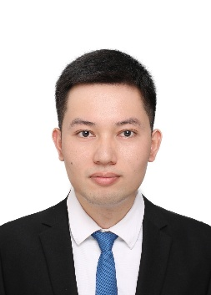
欧增福，男，博士，讲师。2024年获得中山大学凝聚态物理博士学位。主要研究方向：低维碳基体系的电子学、磁学性质的原子尺度研究。研究手段：扫描隧道显微术、第一性原理计算等。在石墨烯纳米带的磁性调控和碳基自旋链的制备与量子磁性探索上取得重要成果，在 Sci. China Phys. Mech. Astron.、Nano Res.、Chem. Mater. 等学术期刊上发表论文多篇。
电子邮箱：ouzengfu@glut.edu.cn
二、代表性的成果
Zengfu Ou, Jun Wang, Jihai Zhang, Yukang Ding, Shenwei Chen, Wenya Zhai, Jingcheng Li*, Dingyong Zhong* and Donghui Guo*, Uncovering the magnetic response of open-shell graphene nanostructures on metallic surfaces at different doping levels. Sci. China Phys. Mech. Astron. 67, 226812 (2024).
Wenya Zhai#, Zengfu Ou#, Haoyuan Zang#, Ye Chen, Yukang Ding, Donghui Guo*, and Jingcheng Li*, On-surface synthesis and collective spin excitations of antiferro- magnetic spin-1/2 polymer chains. Nano Res. (2025).
Shenwei Chen#, Hao Wang#, Zengfu Ou, Hao Liu, Jie Zhou, Peng Hu, Yongqing Wang*, Dingyong Zhong* and Hongbing Ji*, On-surface synthesis of 2D porphyrin-based covalent organic frameworks using terminal alkynes. Chem. Mater. 33, 8677–8684 (2021).
Shenwei Chen, Zeying Cai, Zengfu Ou, Zhiqiang Wang, Donghui Guo and Dingyong Zhong*, Direct aryl–aryl coupling of pentacene on au(110). Phys. Chem. Chem. Phys. 23, 22155–22159 (2021).

